AWS Task-3

Task Description:

- Create a S3 bucket, with no public access and upload files to the bucket & view the logs using cloudwatch for the uploaded files.
S3 Bucket: No public access:
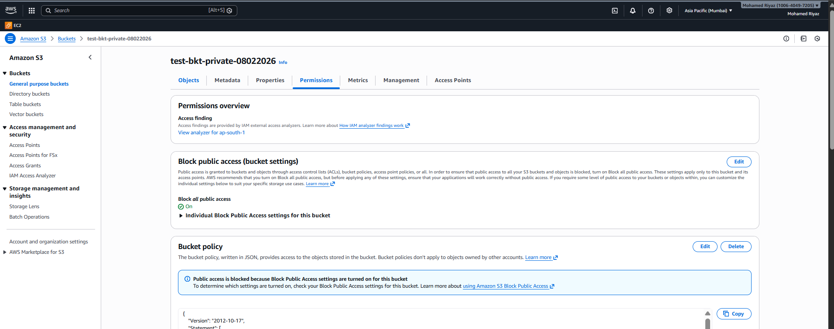
Files Uploaded:
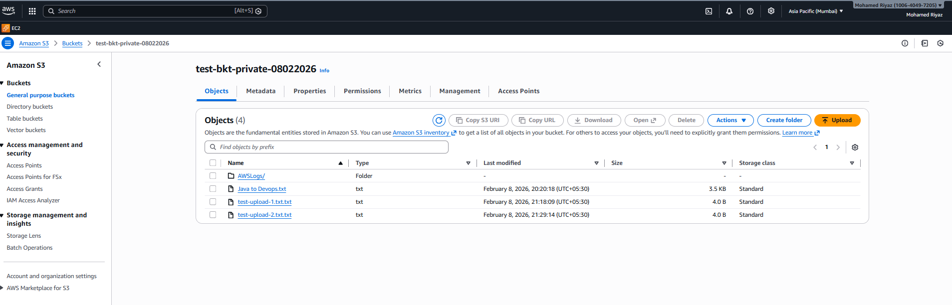
Cloud Trail creation:
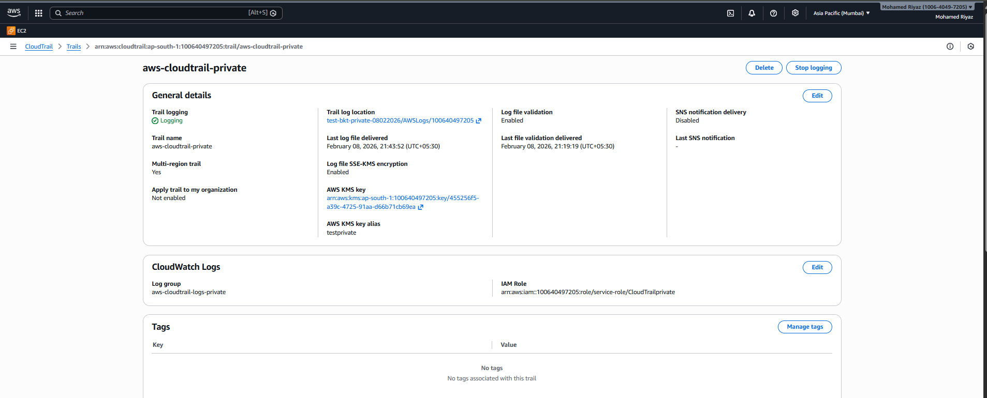
Cloud watch:
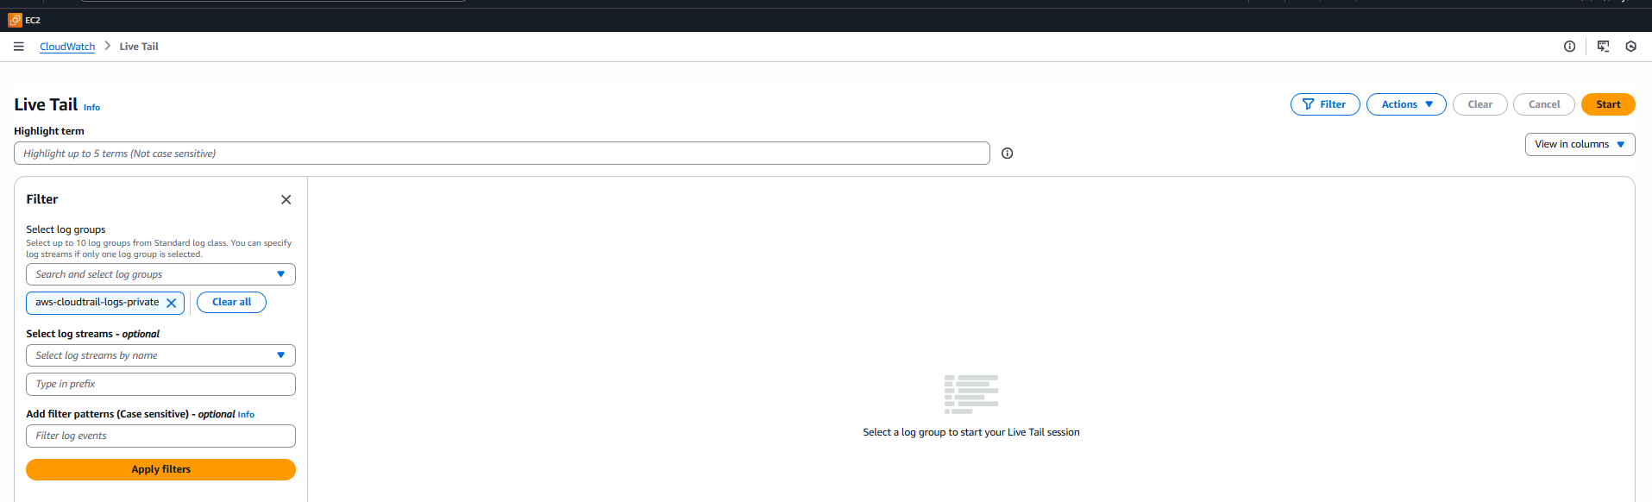
Cloud Watch Logs:
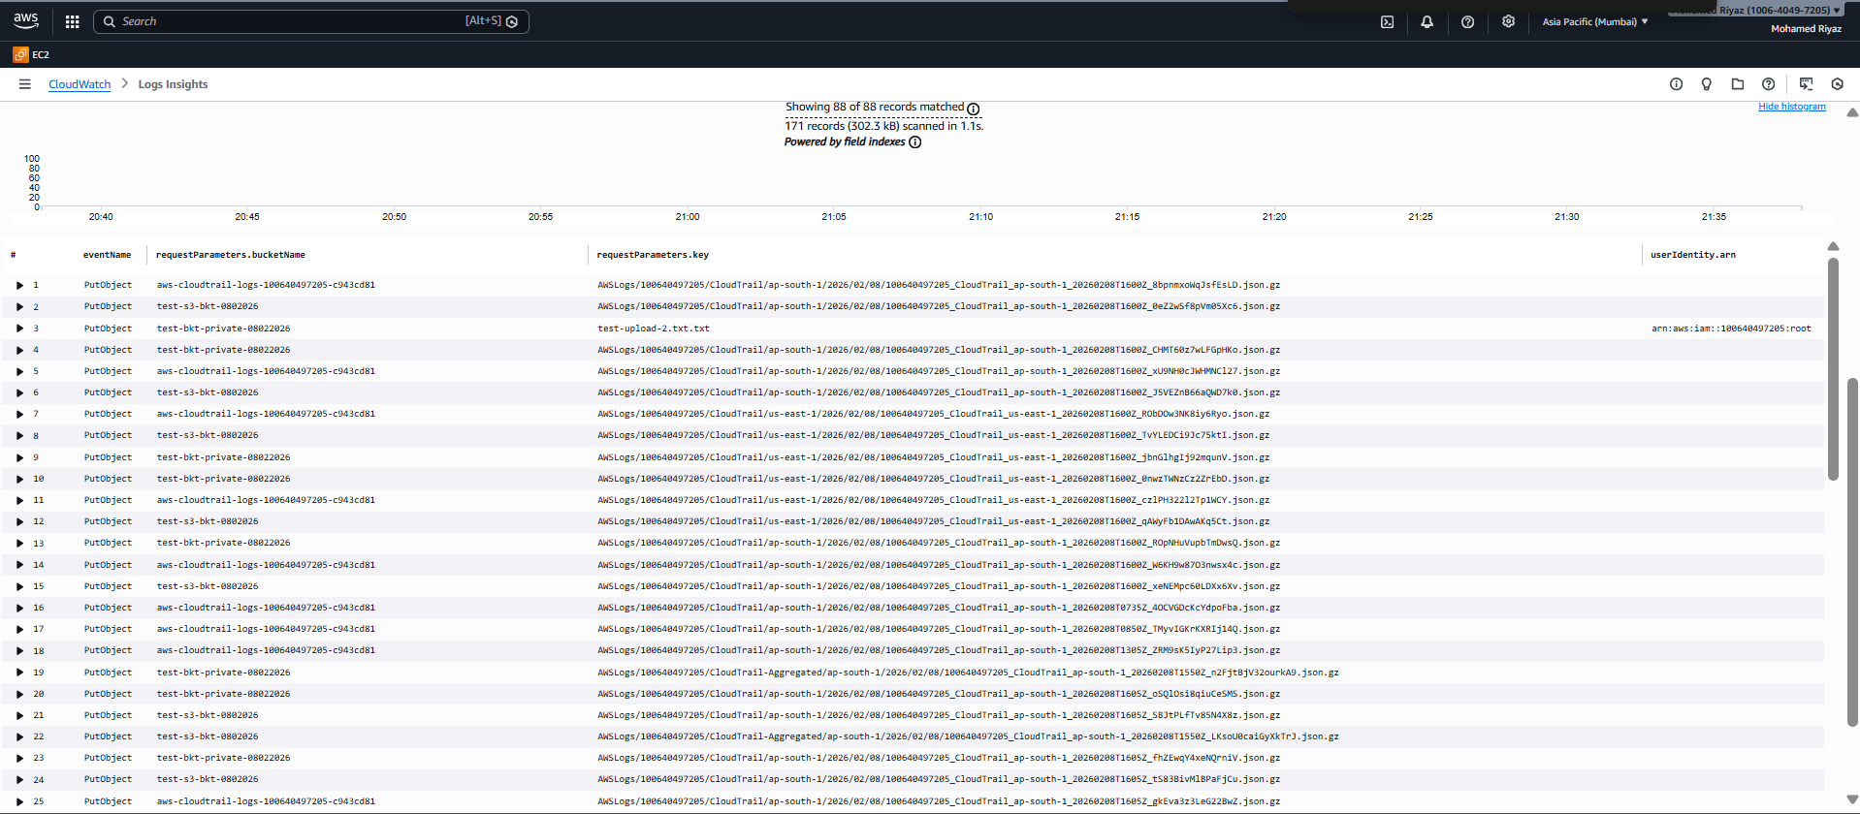

Task:2
Launch two ec2-instances and connect it to a application load balancer, where the output traffic from the server must be an load balancer IP address
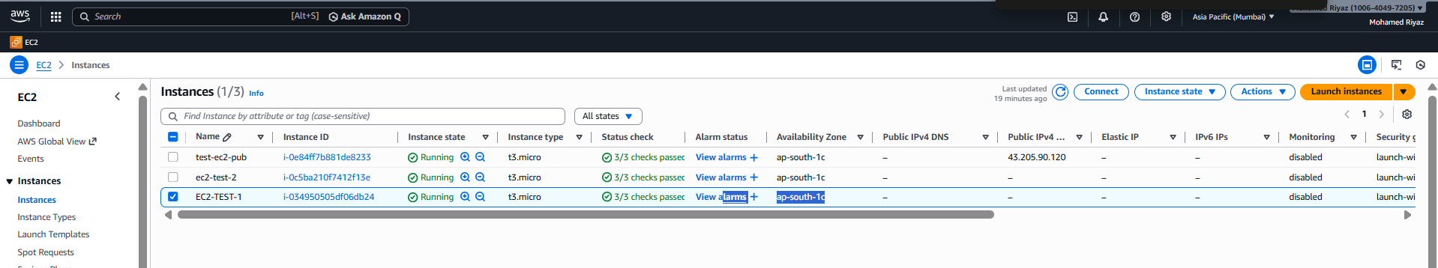

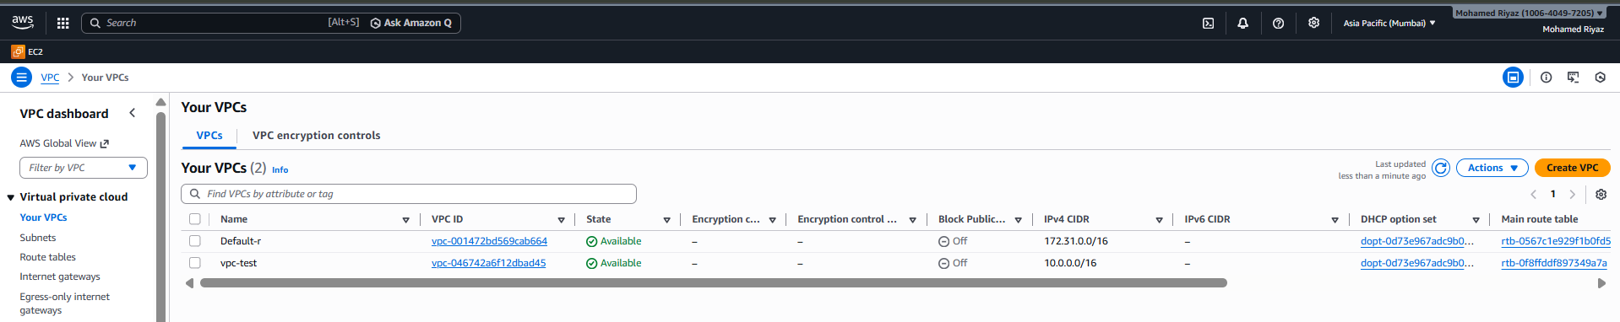

ALB:
